# Name:=Purva Tagde

# PRN:=23070521111

**Practical 07**

**Write and execute PL/SQL function to print /return binary equivalent of decimal number.**

# Introduction

A PL/SQL function is a subprogram that computes and returns a value. It helps in reusability, modular programming, and efficient database operations.

# Key Concepts Used in This Program

* Functions in PL/SQL: A function must have a return type and return a value.
* Loops in PL/SQL: We use loops to repeatedly divide the decimal number by 2 to obtain its binary equivalent.
* String Operations: We build the binary number as a string.

# PL/SQL Function to Convert Decimal to Binary Steps to Convert Decimal to Binary in PL/SQL

1. Take a decimal number as input.
2. Use a LOOP to repeatedly divide the number by 2.
3. Store the remainders (0 or 1) in reverse order.
4. Return the final binary string.

# PL/SQL Function Code

CREATE OR REPLACE FUNCTION decimal_to_binary(n IN NUMBER) RETURN VARCHAR2 IS binary_result VARCHAR2(100) := ''; -- Variable to store the binary equivalent num NUMBER := n; -- Copy of the input number remainder NUMBER; -- Stores remainder after division BEGIN

-- Check for zero case

IF num = 0 THEN

RETURN '0';

END IF;

-- Loop to convert decimal to binary WHILE num > 0 LOOP remainder := MOD(num, 2); -- Get remainder when divided by 2 binary_result := remainder || binary_result; -- Build binary string in reverse num := TRUNC(num / 2); -- Reduce number by dividing by

2

END LOOP;

RETURN binary_result; -- Return final binary value

END decimal_to_binary;

/

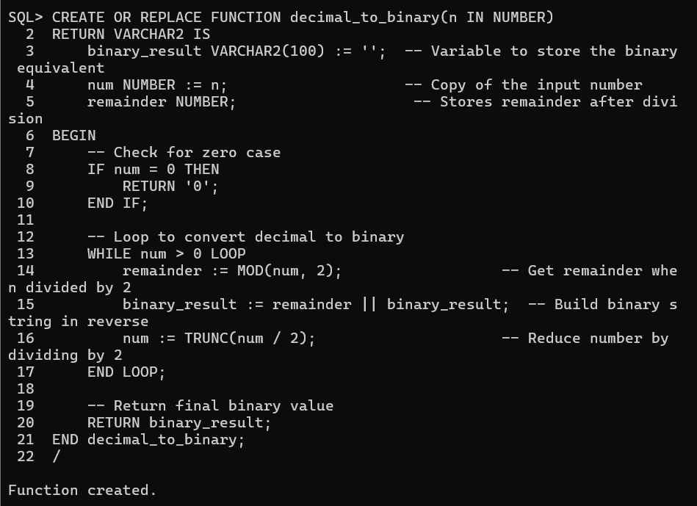

# How to Execute the Function Call the Function Using PL/SQL Block

DECLARE decimal_num NUMBER := 10; -- Example decimal number binary_value VARCHAR2(100); BEGIN

binary_value := decimal_to_binary(decimal_num);

DBMS_OUTPUT.PUT_LINE('Binary equivalent of ' || decimal_num

|| ' is: ' || binary_value);

END;

/

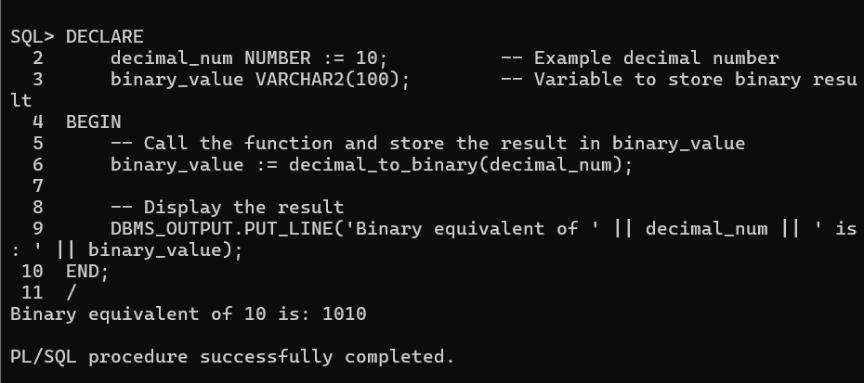

**Expected Output:**

**Binary equivalent of 10 is: 1010**

# Explanation of the Code

|  |  |
| --- | --- |
| **Step** | **Description** |
| Function Creation | Defines decimal_to_binary function with input n (decimal number). |
| Binary Result  Variable | Stores the binary representation as a string. |
| Loop Execution | Repeatedly divides num by 2, storing remainders. |
| String Concatenation | Builds binary number in reverse order. |
| Return Statement | Returns the final binary string. |

# Task

1. Modify the function to display step-by-step conversion while calculating binary.

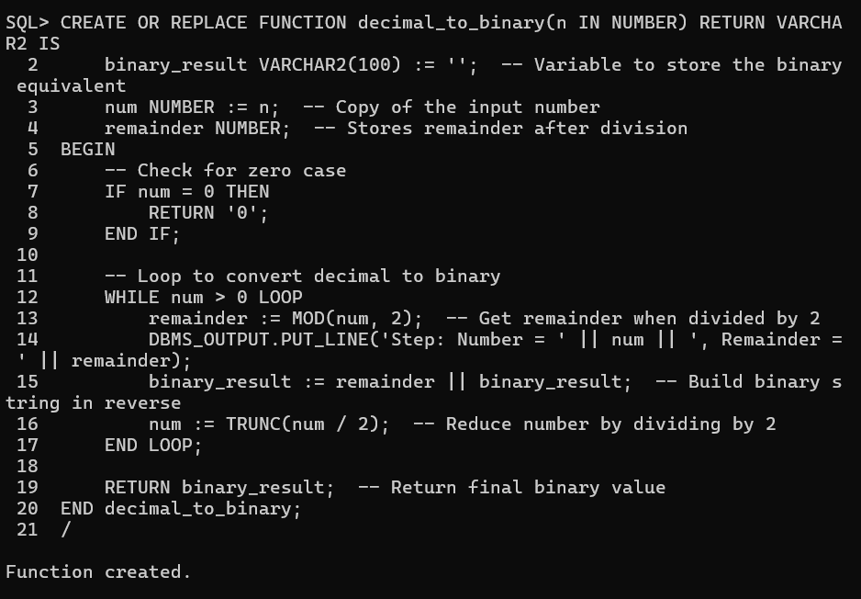

1. Write a PL/SQL block to accept user input for the decimal number and call the function.

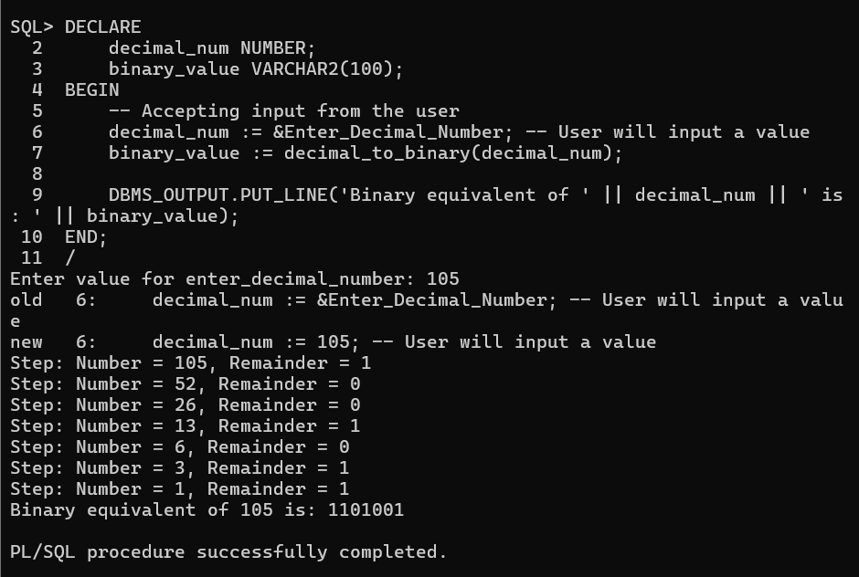

1. Modify the function to store binary values in a table (binary_conversions).

